**Table of Content**

**Abstract**

* + Overview of the system and its objectives

**Acknowledgment**

* + Appreciation for contributors and resources.

**Chapter 1: Introduction**

* + 1.1 Purpose
  + 1.2 Problem Statement
    - 1.2.1 Problem Background
    - 1.2.2 Problem Description
    - 1.2.3 Problem Reasoning
  + 1.3 Goals and Objectives

Goal 1: Enhance User Experience and Accessibility

Objective 1.1: Intuitive and Responsive User Interface

Objective 1.2: Platform Accessibility for Diverse User Demographics

Objective 1.3: Personalized Dashboard for Users

Goal 2: Efficient Trip Planning and Management

Objective 2.1: Multi-Destination Itinerary Creation

Objective 2.2: Interactive Maps for Route Planning

Objective 2.3: Personalized Recommendations for Travel Services

Goal 3: Real-Time Updates and Notifications

Objective 3.1: Live Flight, Hotel, and Transport Updates

Objective 3.2: Weather Alerts, Local Events, and Safety Notices

Objective 3.3: Time-Sensitive Alerts and Notifications

Goal 4: Budget Planning and Cost Management

Objective 4.1: Budget Tracker for Travel Expenses

Objective 4.2: Cost-Effective Travel Service Recommendations

Objective 4.3: Alerts for Budget Exceedance

Goal 5: Collaboration and Social Features

Objective 5.1: Multi-User Collaboration on Trip Planning

Objective 5.2: Integrated Group Communication Tools

Objective 5.3: Review and Rating System for Travel Services

Goal 6: Security and Privacy

Objective 6.1: Data Encryption for User Information

Objective 6.2: Secure Authentication Methods

Objective 6.3: Compliance with Data Protection Regulations

Goal 7: Continuous Improvement and System Scalability

Objective 7.1: Regular Updates Based on User Feedback

Objective 7.2: Scalability for Peak Traffic Handling

Objective 7.3: Analytics and Performance Monitoring for System Refinement

* + 1.4 System Development Life Cycle (SDLC)
    - 1.4.1 Idea Generation & Planning
    - 1.4.2 Requirement Gathering
    - 1.4.3 Analysis & Design
    - 1.4.4 Development
    - 1.4.5 Testing
    - 1.4.6 Deployment
    - 1.4.7 Maintenance
  + 1.5 Avijatri System Overview
    - **1.5.1 Tourist Guide**
      1. Role of the Tourist Guide
      2. Features of the Tourist Guide
      3. Interaction with the Avijatri System
    - **1.5.2 Hotel Management**
      1. Role of Hotel Management
      2. Features of Hotel Management
      3. Interaction with the Avijatri System
    - **1.5.3 VIP Tourist Customization**
      1. Role of VIP Tourist Customization
      2. Features of VIP Tourist Customization
      3. Interaction with the Avijatri System
    - **1.5.4 Tourist**
      1. Role of the Tourist in the System
      2. Features for Tourists
      3. Interaction with the Avijatri System
    - **1.5.5 Trip Management**
      1. Role of Trip Management
      2. Features of Trip Management
      3. Interaction with the Avijatri System
    - **1.5.6 Billing System**
      1. Role of the Billing System
      2. Features of the Billing System
      3. Interaction with the Avijatri System
    - **1.5.7 Transportation Management**
      1. Role of Transportation Management
      2. Features of Transportation Management
      3. Interaction with the Avijatri System
    - **1.5.8 System Diagram**
      1. Conceptual Design of the Avijatri System
      2. Overview of System Integration
      3. Diagram Representation

**Chapter 2: System Study or Information Gathering**

* + 2.1 Introduction
  + 2.2 Information Sources
    - 2.2.1 Internal Sources
    - 2.2.2 External Sources
  + 2.3 Information Gathering Methods
  + 2.4 Benchmark Analysis
  + 2.5 Gap Analysis

**Chapter 3: System Analysis**

* + 3.1 Introduction
  + 3.2 SWOT Analysis
  + 3.3 Feasibility Analysis
    - 3.3.1 Technical Feasibility

**3.3.1.1 Technology Stack**

* + - * + Frontend Development
        + Backend Development
        + Database Management
        + Infrastructure
        + Third-party Integrations
      1. **Scalability and Performance**
* Expected Traffic
* Performance Benchmarks
* Load Balancing and Caching

**Security and Compliance**

* + - * + Data Encryption
        + Authentication
        + Compliance Standards
        + Vulnerability Assessments

**Development Tools and Resources**

* + - * 1. Version Control
        2. Project Management
        3. Testing Tools

**Resource Requirements**

* + - * 1. Human Resources
        2. Budget Allocation

**Risk Assessment and Mitigation**

* + - * 1. Identified Risks
        2. Mitigation Strategies

**Conclusion**

* + - 3.3.2 Economic Feasibility
    - 3.3.3 Behavioral Feasibility
    - 3.3.4 Legal Feasibility
  + 3.4 Feature List Fixation
  + 3.5 Specific Requirements
    - 3.5.1 Functional Requirements
    - 3.5.2 Non-Functional Requirements

**Chapter 4: System Design**

* + 4.1 Context Diagram
  + 4.2 Use Case Diagram and Descriptions
  + 4.3 Class Diagram
  + 4.4 Sequence Diagram
  + 4.5 Activity Diagram
  + 4.6 Swimlane Diagram
  + 4.7 Data Flow Diagram (DFD)
  + 4.8 Entity-Relationship (ER) Diagram
  + 4.9 Deployment Diagram
  + 4.10 State Diagram

**Chapter 5: Prototype and UI Design**

* + 5.1 Introduction
  + 5.2 Prototyping Tools
  + 5.3 Steps of UI Design
    - 5.3.1 Rules of UI Diagram
  + 5.4 User Interface (UI) Designs
    - 5.4.1 Three Golden Rules
    - 5.4.2 Shneiderman’s Eight Golden Rules
    - 5.4.3 Norman’s Design Principles
  + 5.4 Sitemap

**Chapter 6: Conclusion and Future Work**

* + 6.1 Summary
  + 6.2 Testing and Validation Framework
  + 6.3 Limitations and Challenges
  + 6.4 Insights Gained
  + 6.5 Recommendations for Future Work

**References**

* + Include all cited research papers, articles, and resources.

**Appendices**

* Supporting documents, diagrams, or additional data.

**Abstract**

In today's fast-paced world, travel planning has become integral to modern living, yet it remains a complex and time-consuming process for many. The Travel Planning System, developed under the name "Avijatri," is designed to address travelers' challenges in organizing their journeys. The system aims to simplify travel planning by offering an all-in-one platform that combines personalization, convenience, and real-time updates.

The primary objective of the system is to enhance the travel experience through features such as ticket booking, hotel reservations, tour guide services, and VIP customization options. By leveraging advanced analytics, real-time data, and user-friendly interfaces, the system ensures a seamless journey from start to finish. Additionally, the platform emphasizes sustainability and affordability, catering to the needs of diverse travelers while promoting eco-conscious practices.

Avijatri's innovative approach bridges the gap between user expectations and existing travel solutions. It integrates modern technologies like chatbots, dynamic pricing, and API-driven services to deliver reliable, scalable, and secure functionalities. By addressing these critical travel challenges, the system aspires to redefine how individuals plan and experience travel, fostering stronger connections between users and the world they explore.

**Acknowledgment**

We are deeply grateful to Dr. Sumon Sir, our esteemed course instructor for System Analysis and Design (SAD), for his invaluable guidance, constructive feedback, and unwavering support throughout the development of this Software Requirements Specification (SRS) document for the travel planning system, Avijatri. His expertise and encouragement have been pivotal in refining our concepts and aligning them with best practices in system design.

We also extend our heartfelt thanks to our team members, who have worked tirelessly to ensure the successful completion of this report. Their dedication and collaboration have been critical in bringing this vision to life.

Additionally, we acknowledge the resources and platforms that contributed to this project. The insights gathered from competitor analysis, user feedback, and industry research provided the foundation for crafting a comprehensive and user-centric solution. We are particularly grateful for the opportunity to study and evaluate existing systems like GoZayaan and Flight Expert, which helped identify key areas for innovation and improvement.

Lastly, we thank our peers, friends, and families for their continuous support and encouragement during the course of this project. Without their motivation and patience, this work would not have been possible.

We hope that this document serves as a step forward in addressing the challenges faced by modern travelers and contributes meaningfully to the field of travel planning systems.

**Chapter 1**

**Introduction**

The travel industry has experienced significant growth and transformation, driven by the increasing adoption of digital solutions. However, the process of planning and managing travel remains a complex and challenging task for many individuals. Travelers often encounter difficulties navigating multiple platforms to book flights, secure accommodations, and organize activities, leading to inefficiencies and frustration.

To address these challenges, the Travel Planning System, branded as "Avijatri," has been conceptualized to streamline and enhance the travel planning experience. Avijatri aims to provide a unified platform that integrates a wide range of services, including ticket booking, hotel reservations, and tour management, all within a user-friendly and personalized interface.

The system leverages modern technologies such as advanced analytics, real-time data integration, and AI-driven recommendations to deliver tailored solutions that cater to the unique preferences of each traveler. Additionally, Avijatri emphasizes affordability, sustainability, and convenience, ensuring that users can plan their journeys confidently and effortlessly.

By bridging the gaps in existing solutions and focusing on customer-centric features, Avijatri aspires to redefine the travel planning process, offering a seamless, reliable, and enjoyable experience for all users. This initiative not only simplifies travel planning but also fosters stronger connections between individuals and the world they wish to explore.

**1.1 Purpose**

The primary purpose of the Travel Planning System, "Avijatri," is to provide a seamless and comprehensive solution to the complexities associated with travel planning. This system aims to streamline the processes of ticket booking, hotel reservations, tour guide management, and itinerary customization while ensuring user convenience, affordability, and sustainability. By leveraging modern technology and user-centric design, Avijatri seeks to deliver a personalized travel experience that meets the diverse needs of travelers.

**1.2 Problem Statement**

The travel industry has seen exponential growth in digital solutions, yet the current systems often fail to meet the diverse needs of modern travelers. Users face challenges such as fragmented services, overwhelming choices, and lack of personalization, which create inefficiencies in travel planning. This disjointed experience results in increased stress and limits the ability to enjoy seamless travel arrangements.

The core of the problem lies in the absence of a unified platform that integrates essential travel services such as booking, planning, and real-time updates. Additionally, existing systems often lack advanced features like AI-driven personalization, transparent pricing, and sustainability-focused options. These gaps hinder travelers from achieving a streamlined and enjoyable planning process.

Avijatri aims to address these pain points by offering a cohesive, user-friendly, and technologically advanced solution that enhances the overall travel experience while catering to individual preferences and promoting eco-friendly practices.

**1.2.1 Problem Background**

Travel planning has undergone a dramatic shift in recent years, with more travelers relying on digital solutions to organize their journeys. Despite the growing demand for online travel platforms, existing solutions often fail to meet user expectations due to issues such as complex interfaces, lack of personalization, and fragmented service offerings. These challenges create unnecessary stress and inefficiencies for travelers, diminishing the overall experience.

**1.2.2 Problem Description**

Many travelers face the challenge of navigating a multitude of platforms to fulfill their travel needs, such as booking flights, securing accommodations, and planning activities. This fragmented approach results in:

* Overwhelming choices and decision fatigue.
* Inconsistent or incomplete information.
* Limited options for personalization.
* High costs due to a lack of transparency in pricing.
* Poor integration between various services, leading to inconvenience.

**1.2.3 Problem Reasoning**

These issues stem from:

* A lack of cohesive platforms that unify multiple travel-related services.
* Insufficient adoption of advanced analytics and AI for personalized recommendations.
* Limited integration of real-time data for travel updates and availability.
* An absence of platforms that prioritize user-centric design and sustainability.

**1.3 Goals and Objectives**

The overarching goal of Avijatri is to redefine the travel planning experience by addressing the gaps in current solutions. Specific objectives include:

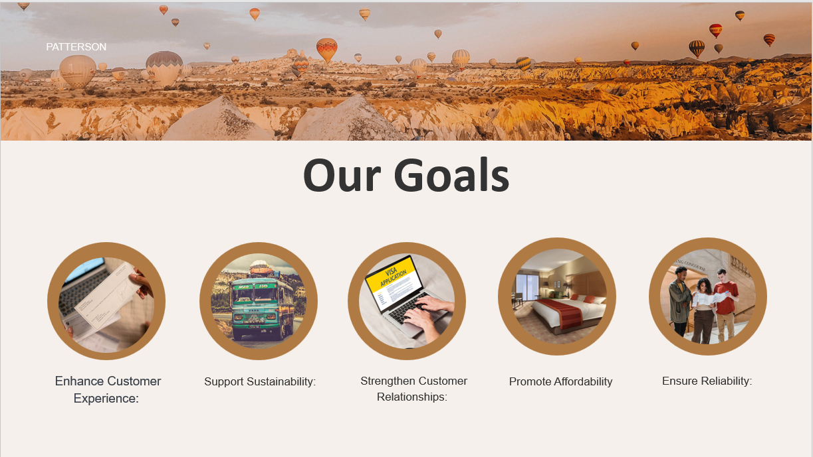

Figure : Description Here

**Goal 1: Enhance User Experience and Accessibility**

**Objective 1.1:** Provide an intuitive and responsive user interface to ensure ease of navigation, making it accessible to all user demographics.

* The system will feature a visually appealing design with user-friendly navigation elements.
* The system will support a mobile-first approach with responsiveness across devices (desktop, tablet, mobile).
* User interfaces will be customizable to reflect individual preferences (e.g., language, theme, font size).

**Objective 1.2:** Implement an accessible platform that caters to users with varying levels of technological expertise and physical capabilities.

* The system will adhere to WCAG (Web Content Accessibility Guidelines) to ensure it is usable by people with disabilities.
* Features will include voice navigation, screen reader compatibility, and keyboard shortcuts.

**Objective 1.3:** Offer personalized dashboards for users to view, manage, and modify their itineraries, travel plans, and preferences in one centralized location.

* The dashboard will include a trip planner, budget tracker, and notifications for important updates.

**Goal 2: Efficient Trip Planning and Management**

**Objective 2.1:** Enable users to create, modify, and manage detailed travel itineraries with multiple destinations and activities.

* Users will be able to add flights, hotel bookings, car rentals, activities, and events for each day of their itinerary.
* The system will provide an easy-to-use interface for adding destinations and planning trip segments.

**Objective 2.2:** Integrate interactive maps to assist in planning routes, estimating travel times, and exploring nearby attractions.

* The system will display dynamic maps with travel distance, time calculations, and route suggestions.
* Users will have access to detailed location information and nearby tourist sites.

**Objective 2.3:** Offer intelligent recommendations based on user preferences, location, and budget for activities, accommodations, and transportation.

* The recommendation engine will leverage machine learning to suggest optimized trip plans.
* Suggestions will be tailored based on user behavior, past preferences, and trending activities.

**Goal 3: Real-Time Updates and Notifications**

**Objective 3.1:** Implement real-time flight, hotel, and transport updates to ensure users are informed of any schedule changes or disruptions.

* The system will track live status of flight arrivals, cancellations, and gate changes.
* Users will be notified of hotel booking changes, cancellations, and transport availability updates.

**Objective 3.2:** Provide weather alerts, local events, and safety advisories during the trip to aid in decision-making.

* Weather forecasts and local events will be integrated into the itinerary for proactive planning.
* Safety notifications related to the user’s current location will be sent if necessary.

**Objective 3.3:** Notify users of time-sensitive actions required, such as booking deadlines, upcoming flight check-ins, and activity reservations.

* Alerts for booking confirmations, activity reservations, and cancellations will ensure that users stay on top of their plans.

**Goal 4: Budget Planning and Cost Management**

**Objective 4.1:** Provide users with tools to set, manage, and track their trip budgets across various categories (transport, accommodation, activities, food, etc.).

* The system will include a budget tracker and cost estimation tool for pre-trip planning.
* Users can allocate a specific amount for each category and monitor their expenses in real-time.

**Objective 4.2:** Suggest cost-effective alternatives for travel services, such as cheaper flights, budget accommodations, or discounts on activities.

* The system will leverage data to offer budget-friendly recommendations without compromising quality.
* Users will be alerted to discounts, deals, and offers based on their preferences.

**Objective 4.3:** Provide alerts if the planned budget is being exceeded and offer recommendations for adjustments to stay within the financial goals.

* Real-time spending tracking and alerting will help users make cost-effective decisions throughout the trip.

**Goal 5: Collaboration and Social Features**

**Objective 5.1:** Allow users to collaborate on trip planning by sharing itineraries, preferences, and schedules with friends, family, or colleagues.

* The system will support multi-user collaboration on trip planning, enabling shared itineraries and group discussions.

**Objective 5.2:** Integrate group communication tools such as in-app messaging or comment threads for joint decision-making during the planning process.

* The platform will feature a built-in chat system for collaborative discussions about travel options.

**Objective 5.3:** Enable users to review and rate destinations, accommodations, transport services, and activities.

* Reviews and ratings will help build a community-driven knowledge base, aiding other travelers in making informed decisions.

**Goal 6: Security and Privacy**

**Objective 6.1:** Ensure the highest standards of data privacy by implementing end-to-end encryption for sensitive user data, including payment and personal information.

* Secure payment gateways and encryption protocols will safeguard all financial transactions and personal data.

**Objective 6.2:** Implement secure authentication methods, including two-factor authentication (2FA) and multi-factor authentication (MFA), to protect user accounts.

* The platform will offer advanced security features, including account recovery and login alerts for suspicious activity.

**Objective 6.3:** Comply with relevant data protection laws and regulations, such as GDPR and CCPA, to ensure user privacy and data security.

* Clear privacy policies and consent mechanisms will be in place to maintain trust with users.

**Goal 7: Continuous Improvement and System Scalability**

**Objective 7.1:** Regularly release updates based on user feedback, market trends, and technological advancements to keep the platform relevant and competitive.

* The system will have an agile update mechanism, allowing for rapid deployment of new features and enhancements.

**Objective 7.2:** Ensure the system is scalable and capable of handling increased traffic, particularly during peak travel seasons.

* The platform will be designed to scale horizontally to accommodate growing numbers of users and data.

**Objective 7.3:** Implement comprehensive analytics tools to monitor system performance, user behavior, and overall satisfaction, enabling continuous refinement of the product.

* The system will include detailed analytics for both administrators and users, ensuring a data-driven approach to improvement.

**1.4 System Development Life Cycle (SDLC)**

The development of the Travel Planning System follows the structured phases of the System Development Life Cycle (SDLC):

**1.4.1 Idea Generation & Planning**

This phase involved brainstorming ideas to create a travel platform addressing market gaps. Research was conducted to identify the needs of target users and the potential for technological innovations to meet these requirements.

**1.4.2 Requirement Gathering**

The requirements were collected through:

* Internal sources, such as team discussions and internal workflow analysis.
* External sources, including user feedback, competitor analysis, and research papers.
* Tools like surveys and Google Analytics for understanding user behavior and preferences.

**1.4.3 Analysis & Design**

In this phase:

* **Gap Analysis** identified deficiencies in existing systems.
* **Feature List Fixation** was performed to finalize the system’s functionalities.
* High-level designs such as use case diagrams, class diagrams, and data flow diagrams were created to visualize the system’s structure.

**1.4.4 Development**

The development phase involved coding and implementation of the planned features using the chosen technology stack. Modular development ensured scalability and ease of debugging.

**1.4.5 Testing**

Rigorous testing was conducted to identify and resolve any bugs or inconsistencies. This included:

* Unit Testing
* Integration Testing
* User Acceptance Testing (UAT)

**1.4.6 Deployment**

The system was deployed on a secure and scalable platform, ensuring optimal performance and availability. Deployment included configurations for payment gateways, APIs, and third-party integrations.

**1.4.7 Maintenance**

Post-deployment, ongoing maintenance activities were planned to:

* Address user feedback and incorporate improvements.
* Ensure system reliability through regular updates and monitoring.
* Adapt to changing user needs and technological advancements.

**1.5 Avijatri System Overview**

The **Avijatri** system is a comprehensive platform designed to manage and optimize the complete travel planning process for users. These users include tourists, VIP tourists, and administrators. The system integrates various components to deliver personalized services, seamless trip management, and financial tracking, ensuring a smooth and enjoyable travel experience. Below are the core components integrated within **Avijatri**:

**1. Tourist Guide**

**Role**: The Tourist Guide component provides users with detailed information about various destinations, attractions, local customs, points of interest, and activities to do during their trip.

**Features**:

* Display recommended tourist sites based on the user's preferences.
* Offer itineraries based on the location and type of trip.
* Provide historical and cultural details to enhance the user’s experience.

**Interaction with Avijatri**:

* The system pulls tourist site information from the guide and suggests activities or tours that match the user’s travel interests.
* Allows for direct booking of guided tours and activities through the system.

**2. Hotel Management**

**Role**: This component handles hotel bookings, availability checks, room preferences, and ensures seamless accommodation management for users.

**Features**:

* Search for hotels based on location, price, star rating, amenities, and user reviews.
* Make, modify, and cancel hotel reservations.
* Support for user-specific preferences such as room types, accessibility features, and booking for special events.

**Interaction with Avijatri**:

* The system accesses the hotel database to display available options that fit within the user’s budget and preferences.
* Allows users to book their accommodations as part of the trip itinerary.

**3. VIP Tourist Customization**

**Role**: This feature provides customized, premium experiences for VIP tourists who require a personalized approach to their travel plans.

**Features**:

* Personalized itinerary planning with exclusive services (e.g., private tours, luxury accommodations).
* Special requests management (e.g., private transportation, exclusive events).
* Priority support for changes, cancellations, and special accommodations.

**Interaction with Avijatri**:

* The system offers a premium interface for VIP tourists, allowing them to fully customize their trip in terms of location, accommodation, activities, and services.
* Access to VIP-specific itineraries, recommendations, and booking options.

**4. Tourist**

**Role**: The core user of the system, tourists use Avijatri to plan, manage, and book their trips.

**Features**:

* Basic trip planning and management, including destination selection, activity booking, and itinerary creation.
* Budget tracking and recommendations for cost-effective travel options.
* Interaction with local services and resources such as transportation, accommodations, and attractions.

**Interaction with Avijatri**:

* Tourists interact with the system for itinerary creation, searching for tours, booking transport, and managing their trips.
* The system provides recommendations, real-time updates, and budget management tools to enhance their experience.

Figure : Description Here

**5. Trip Management**

**Role**: This component allows users to plan, track, and manage every aspect of their trip, including flight schedules, accommodation, transportation, activities, and changes in real-time.

**Features**:

* Create and edit trip itineraries by adding, removing, or modifying components like flights, hotels, transport, and activities.
* Real-time notifications for schedule changes, cancellations, or updates (e.g., weather, transport delays).
* Keep track of bookings and ensure coordination between different services (flights, hotels, tours, etc.).

**Interaction with Avijatri**:

* The system aggregates and displays all aspects of the trip, including transport, accommodations, and scheduled activities, in one view.
* Provides real-time updates on the status of each trip component and allows users to make modifications if necessary.

Figure : Description Here

**6. Billing System**

**Role**: The billing system handles all financial transactions, including payments, refunds, invoicing, and cost breakdowns for the services booked through Avijatri.

**Features**:

* Secure payment gateway integration for processing bookings and purchases (flights, hotels, activities).
* Automatic generation of invoices and payment receipts.
* Cost breakdowns, including taxes, service charges, and discounts.

**Interaction with Avijatri**:

* The billing system is integrated with each service (hotel, transport, activities) to calculate and process payments.
* Tracks the user's expenses and sends alerts if a budget limit is exceeded.

Figure : Description Here

**7. Transportation Management**

**Role**: This component is responsible for managing all transportation-related services, including flight bookings, car rentals, transfers, and public transport options.

**Features**:

* Search and book flights, trains, buses, or other transport options based on the user’s preferences.
* Coordinate with transport providers to ensure timely and efficient travel arrangements.
* Support for rental car bookings, private transfers, and transportation scheduling.

**Interaction with Avijatri**:

* The transportation management system communicates with flight, rental car, and transport providers to show available options and make reservations.
* Displays transportation schedules and updates within the user's itinerary.

Figure : Description Here

**System Diagram:**

**Avijatri** is the central hub that integrates the seven components. Here’s the conceptual design of how they relate to each other:

1. **Avijatri** (Central Node)
   * **Surrounding Components**:
     + **Tourist Guide**
     + **Hotel Management**
     + **VIP Tourist Customization**
     + **Tourist**
     + **Trip Management**
     + **Billing System**
     + **Transportation Management**

**Diagram Representation:**

Here’s a basic conceptual breakdown for visual representation :

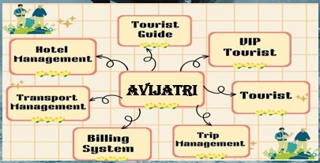

In this diagram, **Avijatri** is at the center, and each surrounding component connects to it. The arrows indicate the interactions between **Avijatri** and its related modules, ensuring seamless integration between all aspects of the trip planning process. The components interact with **Avijatri** to pull data, make bookings, receive real-time updates, and manage user information, creating a fully functional travel management system.

Let me know if you'd like further refinements or details in the system design!

**Chapter 2**

**System Study or Information Gathering**

**2.1 Introduction**

The foundation of a successful system lies in a comprehensive understanding of its requirements and operational environment. This chapter focuses on the systematic study and information gathering undertaken to ensure that the Travel Planning System, "Avijatri," effectively meets user needs and addresses market gaps. By leveraging both internal and external sources, the gathered data forms the basis for a robust and user-centric platform.

**2.2 Information Sources**

**2.2.1 Internal Sources**

Internal sources provided insights from within the organization and team,

including:

Figure

* **Team Collaboration:** Regular brainstorming sessions and discussions among team members to identify functional and non-functional requirements.
* **Workflow Analysis:** Evaluating internal processes to understand the potential system requirements and integration points.
  + <https://www.sciencedirect.com/science/article/abs/pii/S1566253513000705>
  + https://link.springer.com/article/10.1023/A:1012767210241

**2.2.2 External Sources**

External sources helped in gaining a broader perspective on user expectations and industry trends:

* **Competitor Analysis:** Detailed study of platforms like "GoZayaan" and "Flight Expert" to understand their features, strengths, and weaknesses.
* **User Feedback:** Data collection through surveys and interviews with target users to understand their preferences and pain points.
* **Industry Reports and Research:** Reviewing relevant papers, market analyses, and travel industry insights to align with best practices.
* **API and Tool Exploration:** Evaluating third-party APIs using tools like Postman to assess their compatibility and usability for integration.

**2.3 Information Gathering Methods**

To gather the required information, a variety of methods were employed:

* **Surveys and Questionnaires:** Distributed to potential users to collect quantitative and qualitative data on travel preferences and challenges.
* **Focus Groups:** Conducted with small groups of travelers to gain deeper insights into specific pain points and desired features.
* **Observation:** Analyzing how users interact with existing travel platforms to identify usability issues and areas for improvement.
* **Market Research:** Studying current industry trends and user demographics to tailor the system’s offerings.

**2.4 Benchmark Analysis**

Benchmarking was carried out to position Avijatri against existing competitors and ensure it stands out by offering superior value. Key aspects analyzed included:

* **User Interface (UI) and Experience (UX):** Assessing the simplicity and intuitiveness of competing platforms.

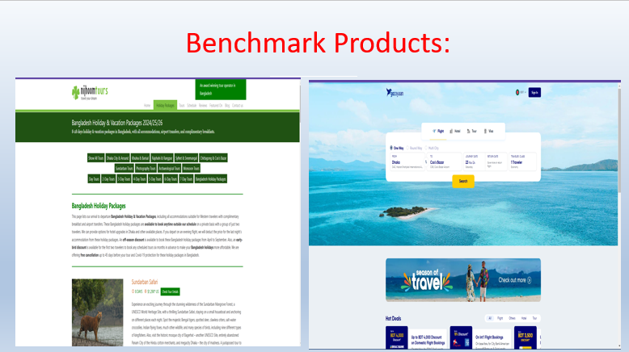

Figure : Description Here

* **Service Range:** Comparing the diversity and comprehensiveness of services offered.
* **Integration:** Evaluating the ability to incorporate real-time updates and third-party services.
* **Pricing Transparency:** Analyzing cost structures and user satisfaction regarding pricing models.
* **Scalability:** Examining how well platforms handle increased user loads and diverse use cases.

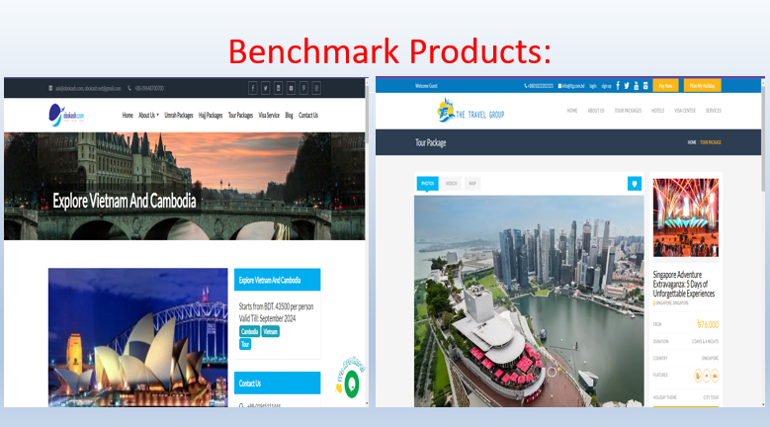

Figure : Description Here

**2.5 Gap Analysis**

The gap analysis identified critical deficiencies in existing travel platforms and highlighted areas where Avijatri could excel. The major gaps included:

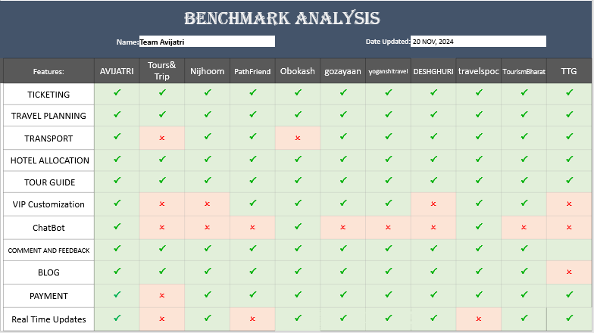

Figure : Description Here

* **Limited Personalization:** Many platforms fail to adapt to individual user preferences and travel history.
* **Real-Time Data Integration:** Absence of dynamic updates on availability, prices, and travel disruptions.
* **Non-Intuitive Interfaces:** Complex navigation and cluttered designs that frustrate users.
* **Sustainability Options:** Lack of eco-friendly travel suggestions or sustainability-focused features.

By addressing these gaps, Avijatri aims to deliver a superior travel planning experience, combining innovation, efficiency, and user satisfaction.

**Chapter 3**

**System Analysis**

**3.1 Introduction**

System analysis is a critical phase in the development process, providing a structured approach to evaluating the system’s components, feasibility, and requirements. This chapter focuses on analyzing the strengths, weaknesses, opportunities, and threats (SWOT) related to the Travel Planning System. It also includes feasibility assessments, feature fixation, and a detailed analysis of functional and non-functional requirements to ensure the system’s success.

**3.2 SWOT Analysis**

The SWOT analysis provides a comprehensive overview of the system’s internal and external factors:

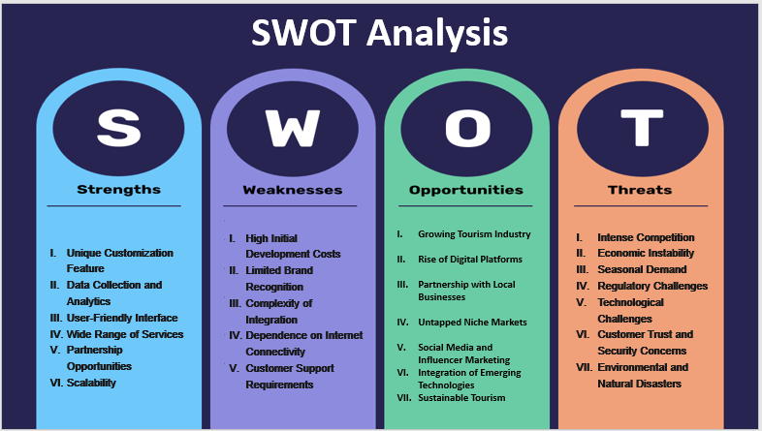

Figure : Description Here

* **Strengths:** Unique customization features, user-friendly interface, and a wide range of services.
  + **Unique Customization Feature**
  + **Data Collection and Analytics**
  + **User-Friendly Interface**
  + **Wide Range of Services**
  + **Partnership Opportunities**
  + **Scalability**
* **Weaknesses:** High initial development costs and dependence on internet connectivity.
  + **High Initial Development Costs**
  + **Limited Brand Recognition**
  + **Complexity of Integration**
  + **Dependence on Internet Connectivity**
  + **Customer Support Requirements**
* **Opportunities:** Growing demand for digital travel platforms, partnerships with local businesses, and integration of emerging technologies.
  + **Growing Tourism Industry**
  + **Rise of Digital Platforms**
  + **Partnership with Local Businesses**
  + **Untapped Niche Markets**
  + **Social Media and Influencer Marketing**
  + **Integration of Emerging Technologies**
  + **Sustainable Tourism**
* **Threats:** Intense competition, regulatory challenges, and economic instability.
  + **Intense Competition**
  + **Economic Instability**
  + **Seasonal Demand**
  + **Regulatory Challenges**
  + **Technological Challenges**
  + **Customer Trust and Security Concerns**
  + **Environmental and Natural Disasters**

**3.3 Feasibility Analysis**

**3.3.1 Technical Feasibility**

This assessment evaluates whether the required technology, tools, and infrastructure are available to implement the system. Avijatri leverages scalable cloud infrastructure, API integrations, and advanced analytics to ensure robust functionality. Here’s a more comprehensive **Technical Feasibility** section for Avijatri. This expanded version includes additional technical details, development strategies, and insights:

**3.3.1.1 Technology Stack**

**Frontend Development**

* **Frameworks**: React.js for dynamic single-page applications or Angular for modular development.
* **Tools**:
  + Figma for wireframing, prototyping, and UI/UX design.
  + Tailwind CSS or Bootstrap for responsive and visually appealing designs.
* **Key Features**:
  + Mobile-first design ensuring compatibility with various devices.
  + Multilingual support for reaching a diverse audience.

**Backend Development**

* **Frameworks**:
  + **Node.js**: Ideal for high-performance and event-driven systems.
  + **Django**: Python-based framework for rapid development with robust security.
  + **Spring Boot**: Java-based framework for enterprise-grade applications.
* **Key Features**:
  + Microservices architecture for scalability and modularity.
  + RESTful APIs for seamless communication between frontend and backend.

**Database Management**

* **Relational Databases**: MySQL or PostgreSQL for structured data.
* **NoSQL Databases**: MongoDB for flexibility in storing travel preferences and logs.
* **Cloud Storage**: Amazon RDS or Firebase for scalability and performance.
* **Backup Strategy**: Automated daily backups using tools like AWS Backup or Google Cloud Backup.

**Infrastructure**

* **Cloud Hosting**:
  + Amazon Web Services (AWS), Microsoft Azure, or Google Cloud Platform for scalability and reliability.
  + Kubernetes for container orchestration and efficient resource management.
* **Content Delivery Network (CDN)**: Cloudflare or Akamai to reduce latency and improve load times globally.

**Third-party Integrations**

* **Payment Gateways**: bKash, Nagad, and SSLCommerz for seamless financial transactions.
* **Travel APIs**: Amadeus, Skyscanner, or TripAdvisor APIs for real-time booking data.
* **Geolocation Services**: Google Maps API for navigation and location-based recommendations.

**3.3.1.2 Scalability and Performance**

* **Expected Traffic**: Initial target of 1–3 million users with infrastructure capable of scaling to 10 million+ users.
* **Performance Benchmarks**:
  + **Response Time**: API responses within 200ms.
  + **Page Load Speed**: Below 3 seconds on standard connections.
* **Load Balancing**: Use of AWS Elastic Load Balancing to distribute traffic efficiently.
* **Caching**: Implementation of Redis or Memcached to reduce load on the database.

**3.3.1.3 Security and Compliance**

* **Data Encryption**:
  + AES-256 for sensitive data storage.
  + TLS 1.3 for secure data transmission.
* **Authentication**:
  + OAuth 2.0 for secure login.
  + Two-factor authentication for additional security.
* **Compliance Standards**:
  + ICT Act 2006 and Consumer Rights Protection Act 2009 for operating in Bangladesh.
  + GDPR compliance for international customers.
* **Vulnerability Assessment**: Regular penetration testing and automated vulnerability scans.

**3.3.1.4 Development Tools and Frameworks**

* **Version Control**: GitHub or GitLab for source code management.
* **Project Management**: Agile methodologies using Jira or Trello for effective team collaboration.
* **Testing Tools**:
  + Selenium for end-to-end testing.
  + Postman for API testing.
  + JUnit or PyTest for backend unit testing.

**3.3.1.5 Resource Requirements**

**Human Resources**

* **Core Development Team**:
  + Frontend Developers (React.js/Angular).
  + Backend Developers (Node.js/Django).
  + Database Administrators.
  + UI/UX Designers.
  + Quality Assurance (QA) Engineers.
* **Support Team**: DevOps Engineers, Technical Writers.

**Budget Allocation**

* Cloud Hosting: $10,000–$20,000 annually.
* API Costs: Variable, depending on usage (e.g., Amadeus, Google Maps).
* Development Tools: $5,000 annually for licenses and subscriptions.

**3.3.1.6. Risk Assessment and Mitigation**

|  |  |  |
| --- | --- | --- |
| **Risk** | **Impact** | **Mitigation Strategy** |
| Dependency on third-party APIs | High | Partner with multiple providers for redundancy. |
| Network Disruptions | Medium | Implement offline access and sync functionality. |
| Data Breaches | High | Regular security audits and real-time monitoring. |
| Scalability Issues | Medium | Use microservices and scalable cloud infrastructure. |

**3.3.1.7. Conclusion**

Avijatri’s technical feasibility is robust, leveraging modern technologies, secure frameworks, and scalable infrastructure. The outlined approach ensures the system’s readiness to deliver a seamless travel planning experience while meeting user demands and industry standards.

**3.3.2 Economic Feasibility**

Economic feasibility focuses on the cost-effectiveness of the project. Initial development costs are balanced by anticipated revenue from user subscriptions, partnerships, and advertisements, ensuring long-term profitability.

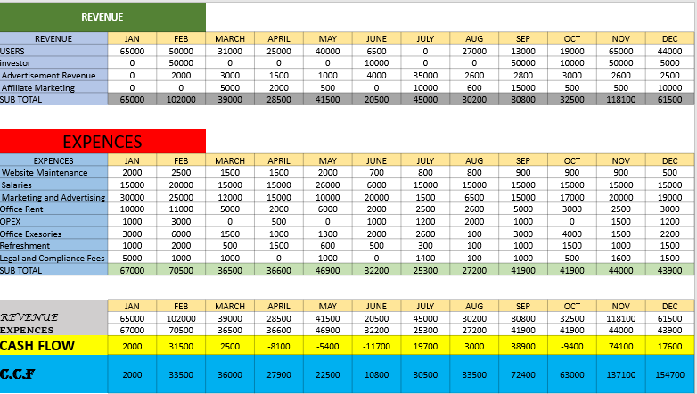

**3.3.3 Behavioral Feasibility**

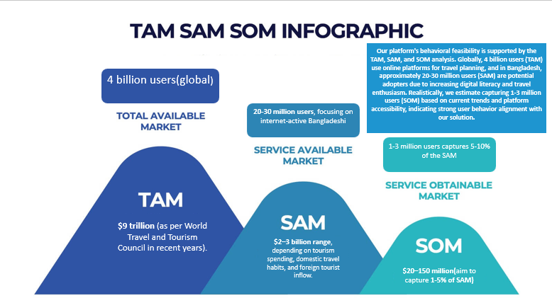Behavioral feasibility assesses user adoption and satisfaction. With features like personalization, real-time updates, and eco-friendly options, Avijatri addresses user expectations and encourages widespread adoption.

**Our platform's behavioral feasibility is supported by the TAM, SAM, and SOM analysis. Globally, 4 billion users (TAM) use online platforms for travel planning, and in Bangladesh, approximately 20-30 million users (SAM) are potential adopters due to increasing digital literacy and travel enthusiasm. Realistically, we estimate capturing 1-3 million users (SOM) based on current trends and platform accessibility, indicating strong user behavior alignment with our solution.**

**3.3.4 Legal Feasibility**

This involves ensuring compliance with regulations such as data protection laws, consumer rights, and intellectual property rights. The system adheres to local and international standards to avoid legal challenges.

1. Business Registration and Licensing

-Register your business with the Registrar of Joint Stock Companies and Firms (RJSC) in Bangladesh.

-ICT Act 2006 for operating an online business in Bangladesh.

2. Data Privacy and Protection

-Privacy Policy and Terms & Conditions

3. Payment Gateway and Financial Transactions

-bKash, Nagad, SSLCommerz

-Bangladesh Bank's guidelines for digital transactions

-Anti-Money Laundering (AML) and Know Your Customer (KYC) policies.

4. Consumer Protection Compliance

-Consumer Rights Protection Act 2009.

5. Intellectual Property (IP)

-Department of Patents, Designs, and Trademarks (DPDT).

-Use licensed APIs and assets (e.g., maps, images) to avoid copyright issues.

**3.4 Feature List Fixation**

Feature fixation defines the system’s core functionalities, such as ticket booking, travel planning, hotel management, real-time updates, and chatbots. These features were selected based on user feedback, market trends, and feasibility studies.

**3.5 Specific Requirements**

**3.5.1 Functional Requirements**

Functional requirements detail the system’s essential operations:

* User registration and profile management.
* Booking and payment integration.
* Personalized recommendations based on user preferences.
* Real-time updates and notifications.

**3.5.2 Non-Functional Requirements**

Non-functional requirements ensure system performance and usability:

* **Scalability:** Ability to handle increased user loads.
* **Security:** Robust data protection measures.
* **Usability:** Intuitive interface for seamless navigation.
* **Reliability:** High uptime and minimal disruptions.

By addressing these aspects, Avijatri aims to deliver a robust and user-focused travel planning system.

**Chapter 4**

**System Design**

**4.1 Context Diagram**

A **Context Diagram** provides a high-level view of the system and its external interactions, showing the system boundary and the actors that interact with it.

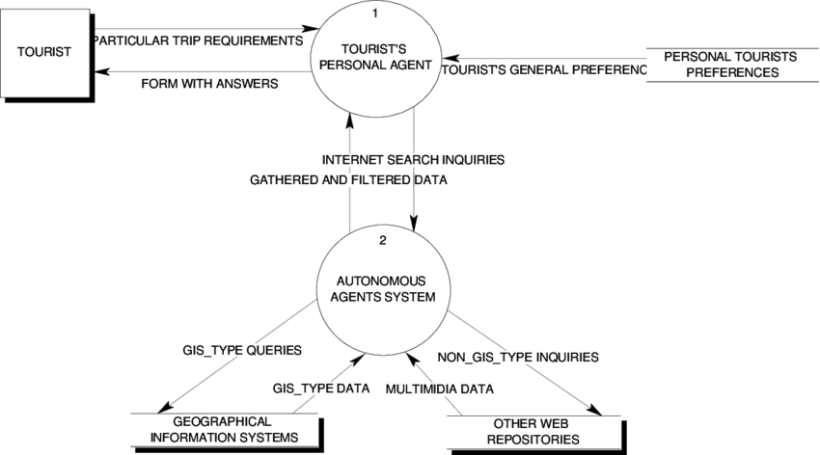

**Avijatri**

**Description**:

* **System Boundary**: The system boundary is a rectangle that separates the Avijatri Travel Planning System from its external actors. Inside this boundary, all the system’s use cases are contained.
* **External Actors**: These are entities that interact with the system, such as:
  + **Traveler**: A user of the system who makes bookings and manages their profile.
  + **Admin**: A user who manages the system’s content, user accounts, and bookings.
  + **Hotel Provider**: External entity that provides hotel data for the system.
  + **Payment Gateway**: An external service responsible for handling payment transactions.

The Context Diagram shows only the basic interactions and is helpful for understanding the high-level flow of data between the system and external actors.

**4.2 Use Case Diagram and Descriptions**

**Description**:

* **Actors**: Traveler, Admin, Hotel Provider, and Payment Gateway.
* **Use Cases**: Register, Search Flights, Book Hotel, Manage Profile, View Itinerary, Review Services, etc.
* The **Use Case Diagram** represents the functionality of the system and its interaction with the external actors in terms of goals and actions.

This diagram helps to visualize the system’s functions and roles clearly.

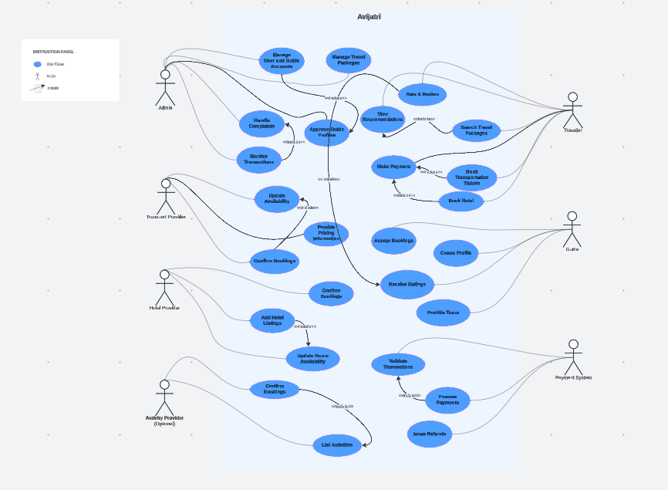

**Use Case 1: Search and Book Travel Packages**

**Primary Actor:**

* Traveler

**Stakeholders & Interests:**

* Traveler: Wants to find and book convenient, affordable, and reliable travel packages.
* Transport Provider, Hotel Provider, Activity Provider: Ensure their services are visible, accurately listed, and booked efficiently.
* Admin: Oversees the quality and accuracy of listings, ensuring smooth operations and user satisfaction.
* Payment System: Handles secure transactions for all bookings.

**Preconditions:**

1. Traveler must have an account and be logged into the system.
2. Transport, hotel, and activity providers must have updated their listings with accurate pricing and availability.

**Success Scenario:**

1. Traveler searches for travel packages using filters such as location, date, and budget.
2. The system provides tailored recommendations based on preferences or past bookings.
3. Traveler selects a package and proceeds to book transportation, accommodation, and activities.
4. The system confirms availability with the respective providers.
5. Traveler makes the payment via the integrated payment system.
6. The payment is validated, and a confirmation is sent to the traveler and providers.

**Alternative Scenarios:**

* If a selected package is no longer available, the system suggests alternative packages.
* If payment fails, the traveler is prompted to try again or use a different payment method.
* If the traveler cancels the booking, the system processes a refund based on the cancellation policy.

**Postconditions:**

1. The booking is confirmed, and all details are updated in the system.
2. Notifications are sent to the traveler and relevant providers.
3. Payment details are recorded, and transaction logs are updated.

**Use Case 2: Manage Travel Providers and Users**

**Primary Actor:**

* Admin

**Stakeholders & Interests:**

* Admin: Ensures only verified and reliable users and providers are part of the platform.
* Travel Providers (Transport, Hotel, Activity): Want to maintain and update their listings to attract travelers.
* Traveler: Expects access to trustworthy providers and accurate service details.

**Preconditions:**

1. Providers must register their profiles and services on the platform.
2. Admin must have access to the provider and user management dashboard.

**Success Scenario:**

1. Admin reviews new provider accounts and approves/rejects them based on verification criteria.
2. Admin monitors listings to ensure they meet platform standards.
3. Providers add or update their listings, including availability and pricing.
4. Admin resolves user complaints or disputes.
5. Providers confirm or resolve bookings as needed.

**Alternative Scenarios:**

* If a provider’s account or listing is flagged for violations, the admin can suspend or remove it.
* If a user reports a service issue, the admin investigates and mediates the dispute.

**Postconditions:**

1. All approved providers are active on the platform, and their listings are visible to travelers.
2. Complaints and disputes are resolved, maintaining the platform’s quality and trustworthiness.

**Use Case 3: Make Payments and Handle Transactions**

**Primary Actor:**

* Traveler

**Stakeholders & Interests:**

* Traveler: Wants a secure, easy, and reliable payment process for their bookings.
* Admin: Ensures transactions are legitimate and resolves payment-related issues.
* Payment System: Validates and processes payments while handling refunds when necessary.

**Preconditions:**

1. Traveler must have an active booking ready for payment.
2. The payment system must be integrated and operational.

**Success Scenario:**

1. Traveler selects a booking and proceeds to payment.
2. The system communicates with the payment gateway to validate the transaction.
3. Payment is successfully processed, and a receipt is generated.
4. Traveler receives a confirmation of payment, and the booking is finalized.

**Alternative Scenarios:**

* If payment validation fails, the traveler is prompted to retry or use another payment method.
* If the traveler cancels the booking, the system initiates a refund request.

**Postconditions:**

1. Payment details are recorded, and transaction logs are updated.
2. Refunds (if applicable) are processed and reflected in the traveler’s account.
3. The booking status is updated to reflect the payment outcome.

**4.3 Class Diagram**

The class diagram for the travel planning system models the static structure of the system, representing the key classes, their attributes, methods, and relationships. It serves as a blueprint for understanding the data flow and interactions between different entities in the system. Each class represents a real-world entity that contributes to the overall functionality of the travel planning application.

**Key Classes and Their Descriptions**

1. **User**:  
   Represents the end-users of the system, such as travelers or administrators.
   * Attributes: user_id, name, username, password, email, phone, dob, gender, address.
   * Methods: register(), login(), logout(), updateProfile().
2. **Itinerary**:  
   Represents a planned journey containing destinations, activities, and bookings.
   * Attributes: itinerary_id, user, destinations, start_date, end_date, budget.
   * Methods: addDestination(), removeDestination(), updateItinerary(), viewItinerary().
3. **Destination**:  
   Represents travel destinations with details about attractions and activities.
   * Attributes: destination_id, name, description, location, attractions, photos_path.
   * Methods: searchDestination(), viewDetails().
4. **Transportation**:  
   Represents available transport options for users.
   * Attributes: transport_id, type, departure, arrival, price, availability.
   * Methods: searchTransport(), bookTransport(), cancelBooking().
5. **Accommodation**:  
   Represents lodging options available for users to book.
   * Attributes: accommodation_id, name, location, type, price_per_night, availability.
   * Methods: searchAccommodation(), bookAccommodation(), cancelBooking().
6. **Booking**:  
   Manages reservations for transportation and accommodations.
   * Attributes: booking_id, user, booking_type, details, amount, status.
   * Methods: confirmBooking(), cancelBooking().
7. **Guide**:  
   Represents travel guides who assist travelers.
   * Attributes: guide_id, name, language, location, expertise, availability, rating, contact_info, hourly_rate, verified.
   * Methods: addGuide(), updateAvailability(), viewProfile(), rateGuide(), bookGuide(), cancelBooking().
8. **Review**:  
   Stores user feedback and ratings for destinations, guides, and services.
   * Attributes: review_id, review_text, user, destination_or_service, rating.
   * Methods: addReview(), editReview(), deleteReview().
9. **Payment**:  
   Handles financial transactions within the system.
   * Attributes: payment_id, user, amount, payment_method, status.
   * Methods: processPayment(), refund().

**Relationships Between Classes**

1. **User and Itinerary**:
   * A **User** can create multiple **Itineraries**, but each **Itinerary** is linked to one **User** (1-to-many relationship).
2. **Itinerary and Destination**:
   * An **Itinerary** can include multiple **Destinations**, but a **Destination** can belong to multiple **Itineraries** (many-to-many relationship).
3. **Itinerary and Booking**:
   * An **Itinerary** can have multiple **Bookings** (e.g., transportation and accommodation). Each **Booking** is linked to one **Itinerary** (1-to-many relationship).
4. **Booking and Transportation/Accommodation**:
   * A **Booking** is associated with either a **Transportation** or **Accommodation** instance (1-to-1 relationship).
5. **User and Review**:
   * A **User** can write multiple **Reviews**, but each **Review** is linked to one **User** (1-to-many relationship).
6. **Review and Destination/Guide**:
   * A **Review** is associated with either a **Destination** or a **Guide** (1-to-1 relationship).
7. **Guide and Booking**:
   * A **Guide** can have multiple **Bookings**, and each **Booking** is linked to one **Guide** (1-to-many relationship).
8. **User and Payment**:
   * A **User** can make multiple **Payments**, but each **Payment** is linked to one **User** (1-to-many relationship).
9. **Payment and Booking**:
   * A **Payment** is associated with one **Booking**, ensuring that financial transactions are tied to reservations (1-to-1 relationship).

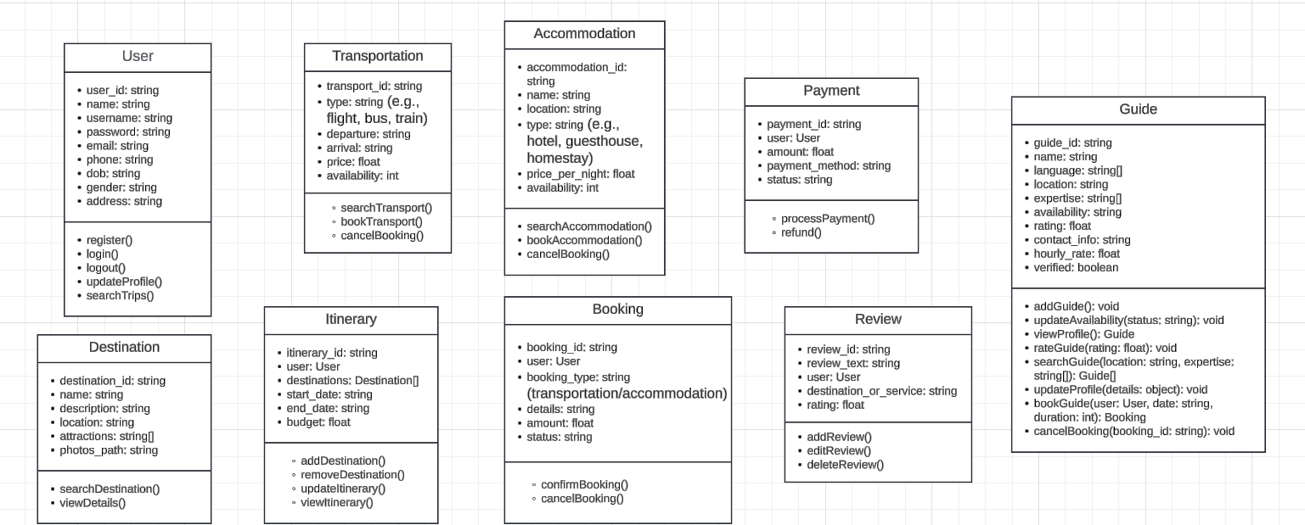

The **Class Diagram** helps define how the objects in the system relate to each other, and their attributes and methods.

**4.4 Sequence Diagram**

A **Sequence Diagram** shows how objects interact in a particular sequence of time, especially how the system's various components communicate with each other to complete a specific process.

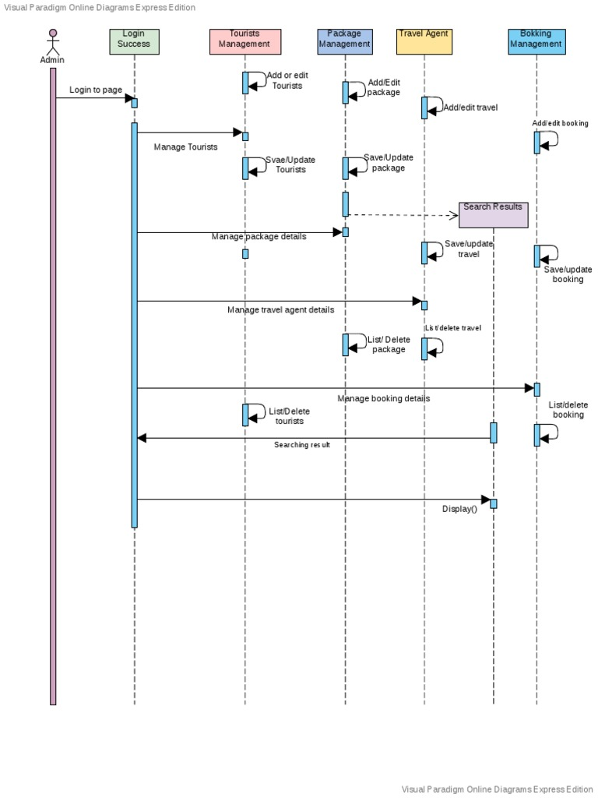

**Description**:

* The **Traveler** interacts with the system by searching for flights and booking them.
* The **System** communicates with the **Hotel Provider** to retrieve hotel information.
* The **Payment Gateway** is involved when processing payments.

Example Sequence for booking a flight:

1. The **Traveler** searches for flights.
2. The **System** retrieves available flights.
3. The **Traveler** selects a flight.
4. The **System** sends booking details to the **Payment Gateway** for payment processing.
5. Once the payment is confirmed, the **Booking** is created and the **Traveler** is notified.

**4.5** [**Activity Diagram**](https://lucid.app/lucidchart/9b9d9274-82bb-4eca-8810-13b4162f60f1/edit?viewport_loc=-4981%2C-458%2C9965%2C4081%2C0_0&invitationId=inv_fa5d46f5-c3d6-43f8-9dee-e2888e788fff)

An **Activity Diagram** shows the flow of control in the system and the activities involved in accomplishing a task.

Link: https://lucid.app/lucidchart/9b9d9274-82bb-4eca-8810-13b4162f60f1/edit?viewport_loc=-4981%2C-458%2C9965%2C4081%2C0_0&invitationId=inv_fa5d46f5-c3d6-43f8-9dee-e2888e788fff

**Description**:

* **Start**: Traveler logs in to the system.
* **Decision**: Check if the traveler has searched for flights.
* **Activities**: Searching for flights, selecting flights, making bookings, entering payment information.
* **End**: Traveler receives confirmation of booking.

The **Activity Diagram** helps visualize the dynamic flow of operations within the system for specific use cases, such as booking a flight or hotel.

**4.6 Swimlane Diagram**

A **Swimlane Diagram** shows the interactions between different actors and how responsibilities are divided across them during a process.

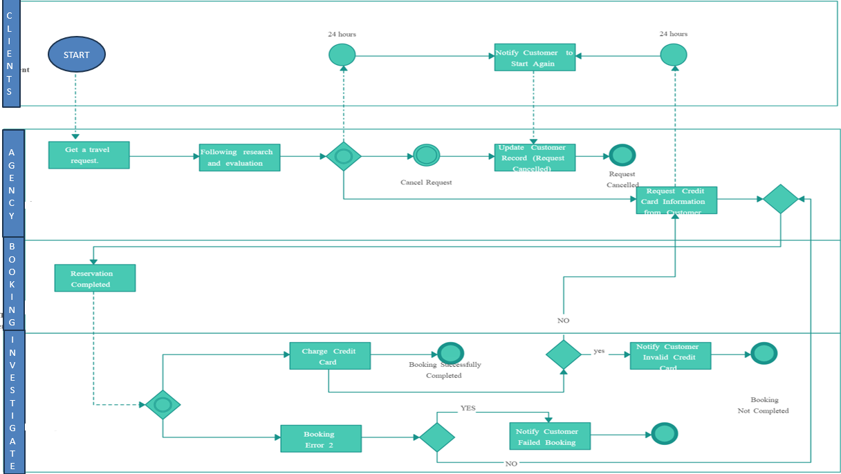

**Description**:

* Each lane in the diagram represents an actor (Traveler, Admin, System, Payment Gateway).
* Activities within each lane show the steps taken by that actor.
* For example, the **Traveler** lane shows actions like searching for flights and making bookings, while the **System** lane shows how the system processes those requests.

The **Swimlane Diagram** provides a clearer view of process responsibilities across different actors and the system.

**4.7 Data Flow Diagram (DFD)**

This DFD illustrates the process of managing and accessing place information within a system. The main users of the system are the **User** and the **Admin**, who interact with the system to input, view, and navigate place data. It also integrates external systems like **Google Maps** for navigation. Below is the detailed description of each process and the data flows..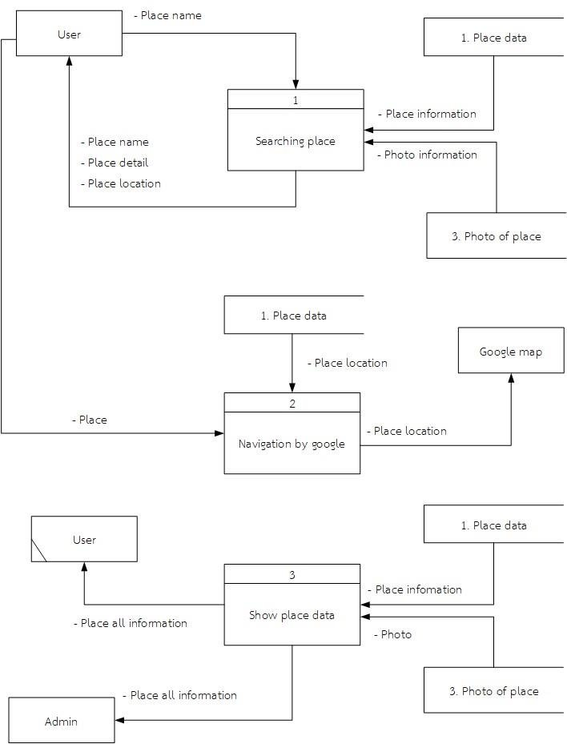

**1. User Input and Searching Place**

* **Entity:**
  + **User**: Provides input such as the **place name** to search for a location.
* **Process 1: Searching Place**
  + The user initiates the process by entering a **place name**.
  + The system retrieves relevant **place information**, including details and location, from the database or storage.
  + The system also fetches related **photo information** for the requested place.
* **Output:**
  + The system returns the **place information** and related **photos** to the user.

**2. Navigation Using Google Maps**

* **Entity:**
  + **User**: Selects a place and requests navigation to the location.
  + **Google Maps**: Used to provide location-based navigation services.
* **Process 2: Navigation by Google**
  + The system sends the **place location** data to Google Maps.
  + Google Maps processes the data and returns navigation information (e.g., routes and directions) based on the input location.
* **Output:**
  + The user receives navigation guidance from Google Maps for the selected place.

**3. Viewing and Managing Place Data**

* **Entities:**
  + **User**: Views the details of a specific place.
  + **Admin**: Manages and updates place information within the system.
* **Process 3: Show Place Data**
  + The system retrieves all relevant **place information** from the database, including photos.
  + Admin ensures the **place data** is accurate and updated, including details such as the name, description, location, and photos.
  + Users can view all this data to make informed decisions.
* **Output:**
  + Place information, along with photos, is displayed to the user.

**Key Data Flows**

1. **From User to Searching Place Process:**
   * Input: **Place Name**
   * Output: **Place Information** and **Photo Information**
2. **From Searching Place to Navigation by Google Process:**
   * Input: **Place Data**
   * Output: **Place Location** sent to Google Maps for navigation.
3. **From Admin to Place Data Management:**
   * Input: **Place All Information** (place name, details, photos, location)
   * Admin ensures accurate data entry and updates.
4. **From Place Data Management to User Display:**
   * Output: **Place Information** and **Photo Information** are shown to the user.

**Preconditions**

1. The system must have an updated database of places, including names, details, photos, and locations.
2. Google Maps integration must be functional for navigation requests.

**Postconditions**

1. Users receive relevant place details and navigation information.
2. Admin ensures the data accuracy and updates are reflected in the system.

**4.8 Entity-Relationship (ER) Diagram**

**1. User: Represents individuals who interact with the system**

* **UserID (Primary Key):** Unique identifier for each user.
* **Username:** Name chosen by the user for login.
* **Password:** Securely stored password for login authentication.
* **Email:** Email address associated with the user's account.
* **Name:** Full name of the user.
* **Address:** Physical address of the user.
* **Phone:** Contact the phone number of the user.

**2. Booking: Records details of each reservation made by users**

* **BookingID (Primary Key):**Unique identifier for each booking.
* **UserID (Foreign Key):** References the user who made the booking.
* **BookingDate:** Date when the booking was made.
* **TotalAmount:**Total amount payable for the booking.
* **Status:** Status of the booking (e.g., pending, confirmed, cancelled).

**3. Flight: Stores information about available flights**

* **FlightID (Primary Key):** Unique identifier for each flight.
* **Airline:** Name of the airline operating the flight.
* **DepartureAirport:** Departure airport for the flight.
* **DestinationAirport:** Destination airport for the flight.
* **DepartureDateTime:** Date and time of departure.
* **ArrivalDateTime:** Date and time of arrival.
* **Price:** Price of the flight ticket.
* **AvailableSeats**: Number of available seats on the flight.

**4. Accomodation: Represents available lodging options**

* **AccommodationID (Primary Key):**Unique identifier for each accommodation.
* **Name:**Name or title of the accommodation.
* **Location:** Location or address of the accommodation.
* **CheckInDate:**Date for check-in.
* **CheckOutDate:** Date for check-out.
* **PricePerNight:** Price per night for the accommodation.
* **AvailableRooms:** Number of available rooms in the accommodation.

**5. Activity: Manages information about activities or tours available**

* **ActivityID (Primary Key):** Unique identifier for each activity.
* **Name:** Name or title of the activity.
* **Location:** Location or address of the activity.
* **Date:** Date of the activity.
* **Time:** Time of the activity.
* **Price:** Price of the activity.
* **Capacity:** Maximum capacity or number of participants for the activity.

**Relationship Between These Entities**

**1. User - Accommodation Relationship (Many-to-Many):**

* Users can book multiple hotels, indicating a user can make bookings for different accommodations.
* Every accommodation can be booked by multiple users, meaning a hotel can have bookings from different users.

**2. User - Booking Relationship (Many-to-One):**

* Many bookings can be associated with one user, showing that a user can make multiple bookings over time.

**3. User - Activity Relationship (Many-to-Many):**

* Users can book multiple activities, allowing a user to participate in various activities.
* Every activity can be booked by multiple users, indicating that an activity can have participants from different users.

**4. Booking - Activity Relationship (Many-to-One):**

* Many activities can be associated with one booking, meaning that a booking can include multiple activities.

**5. Booking - Accommodation Relationship (Many-to-One):**

* Many hotels can be associated with one booking, showing that a booking can include stays at multiple hotels.

**6. Booking - Flight Relationship (Many-to-One):**

* Many bookings can be associated with one flight, indicating that a booking can include a flight reservation.

**ER Diagram of AvijaTri:**

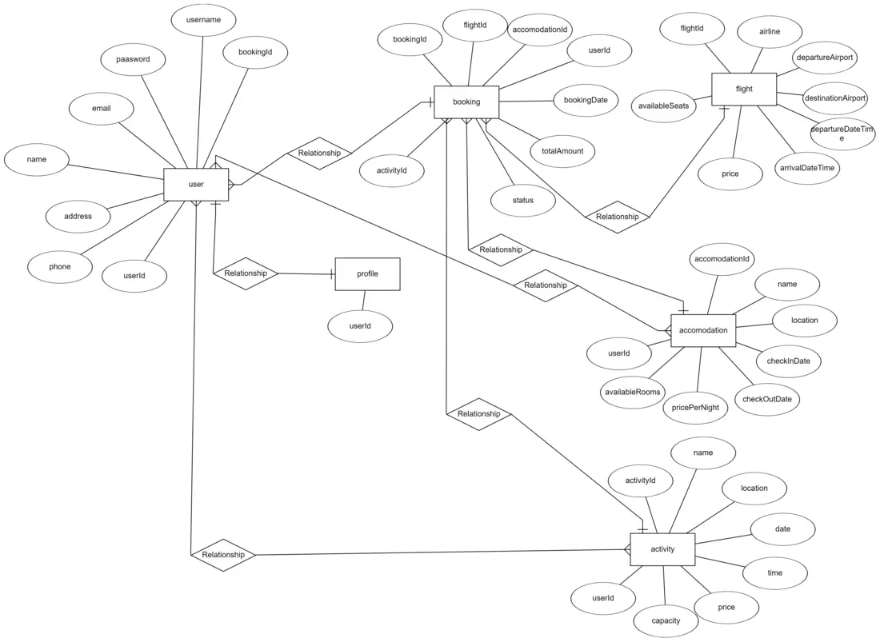

**4.9 Deployment Diagram**

A **Deployment Diagram** shows the physical deployment of the system's components, representing how software components are deployed to hardware.

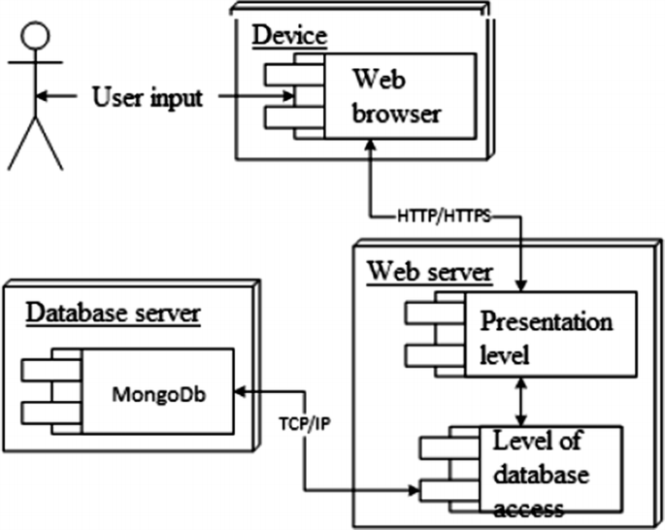

**Description**:

* The **Travel System** is deployed on a cloud-based server.
* The **Database** server stores all the information related to users, bookings, and payments.
* The **Payment Gateway** is hosted externally.
* The **Traveler’s Device** (mobile or desktop) interacts with the **Cloud System** to access and use the platform.

The **Deployment Diagram** ensures that the system is scalable, efficient, and can handle user load across various devices.

**Conclusion**

These diagrams collectively define the **Avijatri Travel Planning System’s** architecture, functionality, and data flow. They provide essential information for system implementation, ensuring that all components work cohesively to provide a seamless user experience. Each diagram serves a unique purpose, helping developers, stakeholders, and users understand the system at different levels of detail.

**Chapter 5**

**Prototype and UI Design**

**5.1 Introduction**

The **Prototype and UI Design** chapter is essential to ensuring that the **Avijatri Travel Planning System** meets the needs of its users. The purpose of this chapter is to provide a clear understanding of the system’s design through visual representations, such as prototypes and user interface (UI) designs, and to outline the tools and methods used to create them. Prototyping serves as an early version of the system that allows both developers and stakeholders to visualize the functionalities before full implementation, providing a feedback loop for refinement. UI design focuses on the user experience, ensuring that the interface is intuitive and accessible.

The user interface design is a critical element of the project, as it directly influences user satisfaction and ease of use. Effective UI design also includes the navigation structure, design elements, and interactive components that allow users to perform tasks such as booking hotels, searching for flights, and managing their travel itinerary with minimal effort.

**5.2 Prototyping Tools**

To create the prototype for the **Avijatri Travel Planning System**, several tools are employed to quickly visualize and test ideas. These tools help in creating interactive wireframes and mockups that simulate the system's functionality. Below are the key tools used for prototyping:

* **Figma**: A popular design tool used for creating high-fidelity wireframes and interactive prototypes. Figma allows collaboration in real-time, making it ideal for team-based design projects.
* **Adobe XD**: Another widely-used prototyping tool for designing user interfaces. Adobe XD helps create interactive prototypes and is integrated well with other Adobe products.
* **Sketch**: A vector-based design tool used to create UI elements and design layouts. Sketch is highly flexible for mobile and web interface designs.
* **InVision**: This tool is used to create clickable prototypes, enabling users to navigate through a simulation of the final application.
* **Axure RP**: This tool is more advanced and allows for creating highly detailed wireframes with complex interactions, making it useful for developing sophisticated prototypes.

These tools help the team visualize the structure and flow of the system early in the design phase, allowing for rapid iteration and feedback.

**5.3 Steps of UI Design**

**1. Planning**

* Objective: Understand customer requirements to lay the foundation for the travel planning system.
* Key Activities:
  + Gather and analyze customer requirements.
  + Perform benchmark analysis by studying similar systems or competitors.
  + Define the overall theme, layout, and navigation structure for the system.

**2. Prototyping & Sketching**

* Objective: Create a visual representation of the system's interface and workflows.
* Key Tools: Figma, Canva, Proto.io, or similar prototyping tools.
* Key Activities:
  + Develop wireframes or rough sketches to represent the system’s design and functionality.
  + Create a demo or mockup to showcase the user interface and flow.

**3. Optimization**

* Objective: Enhance the prototype to improve efficiency and usability.
* Key Activities:
  + Gather feedback from stakeholders or potential users.
  + Analyze and refine the prototypes based on performance, usability, and aesthetic criteria.
  + Ensure alignment with the project’s goals and requirements.

**4. Implementation**

* Objective: Finalize and implement the optimized design.
* Key Activities:
  + Incorporate feedback from the optimization phase into the final prototype.
  + Translate the design into actual system components, integrating functionality and aesthetics.
  + Prepare for system testing and deployment.

**5.4 User Interface (UI) Designs**

The **User Interface (UI) Design** is focused on how the system looks and feels from the user's perspective. A key goal of UI design is to create a clean, efficient, and intuitive experience for the users. The design process begins with the creation of wireframes, followed by developing high-fidelity mockups, and finally creating an interactive prototype for user testing.

**Key UI Design Components**:

1. **Login Screen**: A simple login page where travelers can authenticate themselves to access personalized services such as booking and profile management.
2. **Home Page**: The central dashboard of the system, providing an overview of travel options like flight search, hotel bookings, and tour information.
3. **Search Functionality**: A search interface that allows users to filter and sort through various travel options such as flights, hotels, and vacation packages.
4. **Booking Page**: The page where travelers can select their desired flight or hotel, add travel details, and proceed with booking.
5. **Profile Management**: A user-friendly page that enables travelers to view and update their profile, including personal information, payment methods, and travel preferences.
6. **Payment Interface**: A secure payment page where users can enter their payment details to confirm bookings.
7. **Feedback and Review**: A section where users can leave reviews for hotels, flights, or services they have used.

Each of these UI components is designed to ensure a seamless experience for the user. The design focuses on minimalism, using a modern color palette, clear typography, and appropriate visual elements to keep the user engaged.

**5.4.1 Three Golden Rules of UI Design**

**1. Place Users in Control**

* 1.1 Modeless
* 1.2 Flexibility
* 1.3 Interruptible
* 1.4 Helpful
* 1.5 Forgiving
* 1.6 Navigable
* 1.7 Accessible
* 1.8 Facilitative
* 1.9 Preferences
* 1.10 Interactive

**2. Reduce Users’ Memory Load**

* 2.1 Relieve short-term memory
* 2.2 Rely on recognition, not recall
* 2.3 Provide visual cues
* 2.4 Forgiving
* 2.5 Promote an object-action syntax
* 2.6 Use real-world metaphors
* 2.7 Employ progressive disclosure
* 2.8 Organize effectively

**3. Make the Interface Consistent**

* 3.1 Continuity
* 3.2 Maintain consistency within and across products
* 3.3 Keep interaction results the same
* 3.4 Provide aesthetic appeal and integrity
* 3.5 Encourage exploration

**5.4.2 Shneiderman’s Eight Golden Rules of UI Design**

1. **Strive for Consistency**
   * Use identical design patterns and sequences for similar workflows.
   * Consistent colors, fonts, layout, and terminology across the application.
2. **Seek Universal Usability**
   * Design for all users, regardless of age, culture, or experience.
   * Incorporate navigation tips and shortcuts to ease learning.
3. **Offer Informative Feedback**
   * Keep users informed about system status.
   * Build trust by providing clear feedback for every interaction.
4. **Design Dialogs to Yield Closure**
   * Provide appropriate feedback or a sense of accomplishment upon completing tasks.
5. **Prevent Errors**
   * Guide users seamlessly and minimize the occurrence of errors.
   * Employ effective error prevention mechanisms and messages.
6. **Permit Easy Reversal of Actions**
   * Allow users to undo or redo actions (e.g., Back, Cancel, Undo).
   * Relieve anxiety and encourage exploration.
7. **Let Users Be in Control**
   * Enable users to customize their experience and feel in charge of the interface.
8. **Reduce Short-Term Memory Load**
   * Avoid requiring users to memorize information.
   * Use icons, visual aids, and consistent placements for ease of navigation.

**5.4.3 Norman’s Seven Fundamental Design Principles**

1. **Discoverability**
   * Ensure users can determine the system’s current state and possible actions.
2. **Feedback**
   * Provide immediate responses to users’ actions to confirm progress.
3. **Conceptual Model**
   * Offer clear explanations of how the system works.
4. **Affordance**
   * Match object properties with their perceived actions.
5. **Signifiers**
   * Use indicators to communicate where actions should occur.
6. **Mapping**
   * Ensure controls correspond intuitively to their effects.
7. **Constraints**
   * Guide users step-by-step to complete tasks efficiently and effectively.

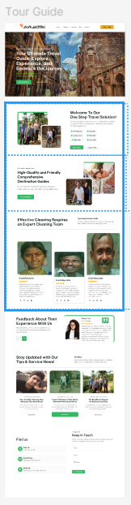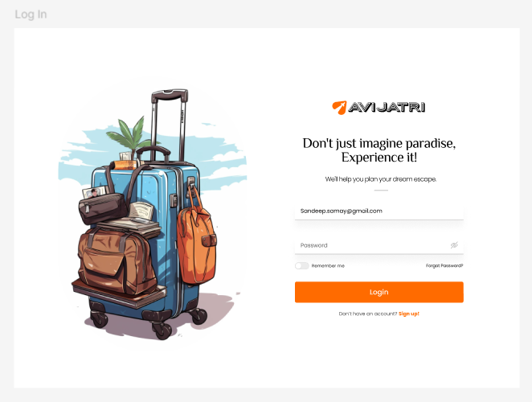

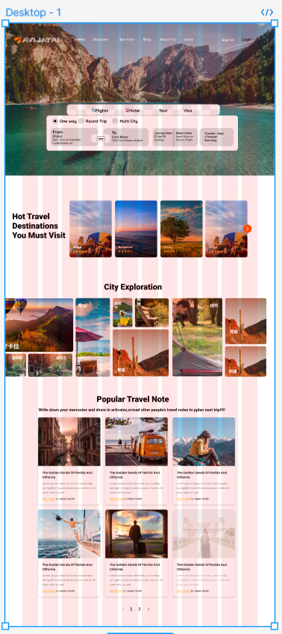

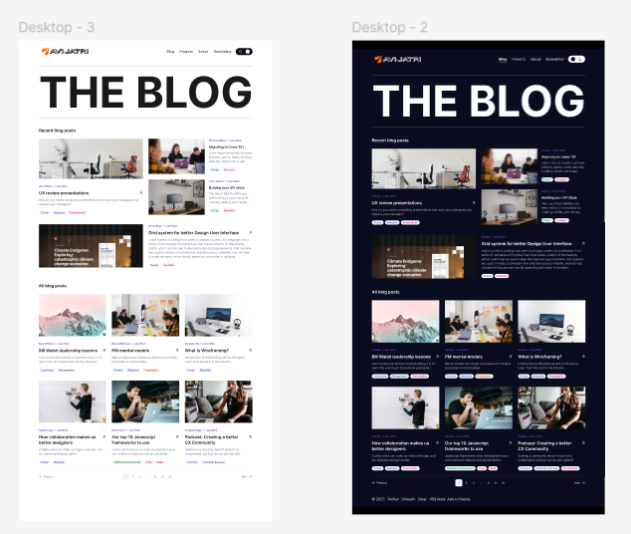

**Round Trip**

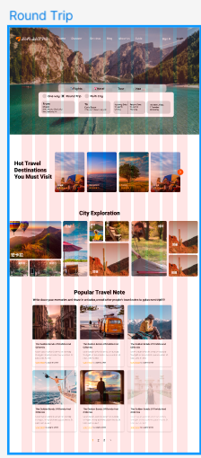

**Multi City**

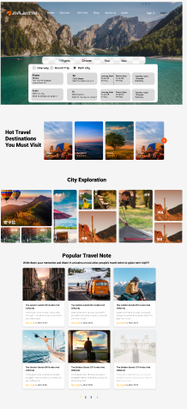

**5.4 Sitemap**

The **Sitemap** represents the structural hierarchy of the website or application and helps define how information and services are organized for easy navigation. In this section, we outline the system’s overall structure, highlighting the key pages and their connections:

**Main Pages in the Sitemap**:

1. **Home Page**:
   * Flight Search
   * Hotel Booking
   * Explore Tours
   * Manage Bookings
   * Profile Settings
2. **Search Results Page**:
   * Filter Options (Date, Price, Location, etc.)
   * Flight or Hotel Details
   * Booking Options
3. **Booking Page**:
   * Review Selections
   * Payment Information
   * Confirmation
4. **User Profile Page**:
   * Personal Information
   * Payment Methods
   * Booking History
   * Reviews and Ratings
5. **Admin Dashboard**:
   * Manage Users
   * View System Analytics
   * Manage Listings (Flights, Hotels, Tours)
   * Handle Payments and Refunds

The **Sitemap** ensures that users can easily navigate through the application to find and book their desired services without confusion. The layout is intuitive, and the logical flow ensures that all necessary pages are readily accessible.

**Chapter 6**

**Conclusion and Future Work**

**6.1 Summary**

This project presents the **Avijatri Travel Planning System**, a solution designed to streamline the process of travel planning by integrating flight booking, hotel reservations, and itinerary management. The system is designed to be user-friendly, offering a seamless experience for travelers to find, book, and manage their travel plans with ease. Through the design of a sophisticated prototype and intuitive user interfaces, the project ensures that all users can interact with the system effectively.

The system has been designed with scalability in mind, enabling the addition of new features and services in the future, such as integrating with third-party travel providers, incorporating AI-driven suggestions, and offering real-time updates on bookings and payments.

**6.2 Insights Gained**

Throughout the development of this system, valuable insights were gained, including:

* The importance of creating a simple, yet functional, UI that allows users to accomplish their tasks with minimal effort.
* The need for efficient data flow management and secure payment gateways, which are critical for user trust.
* The significance of prototyping in gathering early feedback and refining user interface designs before full-scale development.

Additionally, user feedback during the testing phase revealed preferences for features like easy navigation, quick booking, and a personalized travel experience, which will be prioritized in future versions of the system.

**6.3 Recommendations for Future Work**

The **Avijatri Travel Planning System** has significant potential for future growth and improvement. Some recommendations for future work include:

1. **Integration with Third-Party Providers**: Future updates should include the integration of external travel service providers (e.g., flight and hotel booking platforms) to offer more options and competitive pricing to users.
2. **AI-based Recommendations**: Implement AI algorithms to provide personalized travel suggestions based on user preferences, previous bookings, and trends in the travel industry.
3. **Mobile App Development**: In addition to the web platform, developing a mobile app would provide users with more flexibility to manage their bookings and travel itineraries on the go.
4. **Multilingual Support**: To cater to international travelers, adding multilingual support will enhance the system's global appeal.
5. **User-Generated Content**: Enabling users to share their experiences, itineraries, and travel tips could create a sense of community and enhance engagement with the platform.

**References**

In this section, all sources used to gather information, theories, and frameworks are cited. This includes research papers, articles, books, and online resources. Examples of references could include:

1. "UML: A Visual Language for Modeling Software" by Grady Booch.
2. "Responsive Web Design" by Ethan Marcotte.
3. "Prototyping: A Practitioner's Guide" by Todd Zaki Warfel.

The references should follow a consistent citation format (e.g., APA or IEEE style), depending on the preferred guidelines.

❏ https://morioh.com/a/42dc6d4ad6a5/user-interface-design-ui-in-software-engineering  
❏ https://www.uxmatters.com/mt/archives/2022/10/applying-the-8-golden-rules-of-user-interfacedesign.php  
❏ https://yellowchalk.com/blog/8-golden-rules-of-interface-design/  
❏ https://www.linkedin.com/pulse/creating-consistency-ui-design-manjesh-yadav-  
❏ https://www.chameleon.io/inspiration/slack-product-tour-tooltips  
❏ Skyscanner | Find the cheapest flights fast: save time, save money!  
❏ Don Norman's seven fundamental design principles | UX Collective (uxdesign.cc)

❏ https://www.geeksforgeeks.org/software-requirement-specification-srs-format/  
❏ https://www.javatpoint.com/software-requirement-specifications

**Appendices**

The **Appendices** section includes any additional documentation or supporting materials that are relevant to the project. This might include:

* **Detailed Diagrams**: Further diagrams or charts that illustrate system processes, data flow, or technical aspects of the design.
* **Sample Code**: Snippets of code used for prototyping or backend implementation.
* **User Feedback**: Survey results or user feedback collected during prototype testing.

These appendices provide supplementary information that helps clarify the system’s design and implementation process.

This chapter serves as a guide to understanding the design and functionality of the **Avijatri Travel Planning System**, offering insights into its user interface, prototype, and plans for future development.